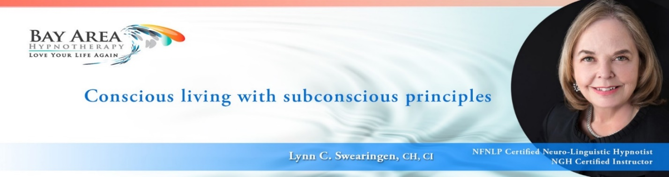

RESOURCES TO BUILD A CONSCIOUS AND RESPONSIBLE BUSINESS PRACTICE

National Guild of Hypnotists
- www.NGH.net
- Download ethics and legal information, continually updated
- Access to training videos, programs, books, etc.
- https://youtu.be/7Xtzb4RKt5w video demonstrating the value of attending the NGH Annual Convention for advanced training.

SBA – Small Business Association https://www.sba.gov/
- Local services and online, to train and support your business in every way.
- Business Loans

HypnoThoughts – Live Training & Hypno Social Network
- http://hypnothoughtscom.jamroomhosting.com/ The free hypnosis social network. Learn hypnosis online with thousands of members and hypnosis videos, forums, blogs, and more.
- https://new.htlive.net/ HypnoThoughts Live may be the most affordable and value packed conference available

How to Market your New Business
Both Dr. Richard Nongard and Jason Linette have outstanding training to ramp up your marketing knowledge/skills and assistance with program development. Dr. Nongard is a premier marketer and the go-to person to learn how to use FaceBook to drive your revenue. Jason Linette is all about building smart systems that work to grow your practice (their info is below)

Rev. C. Scott Giles, NGH resource/advice re legislative, regulatory, legal issues
- Short youtube video shows him addressing some legal issues: https://www.youtube.com/watch?v=KRtwMqpkbyI
- https://youtu.be/kSTYBu9pE-M video regarding appropriate language e.g. Obesity is now classified as a disease, which makes it a medical issue. Learn how to work with weight management without using inappropriate language

Balazs Laszlo Karafiath, PhD

Laszlo was my partner in previous NGH certification training. He is an outstanding leadership coach, describing himself as a purpose coach, and a Liminal Coach. Laszlo is an expert working with corporations and groups, an excellent resource to learn more about how to work with leaders, change-makers and their organizations, using his Purpose Anchored Transformation methodology.
https://www.purposeandplay.com/aboutus#welcome
At the very least, sign up for his blog: https://www.purposeandplay.com/purposeandplayblog
The purpose driven organization: https://www.purposeandplay.com/#purpose-driven-organization
Dr William D. Horton, Psy.D, CADC, CI, MH
https://nfnlp.com/WilliamHorton_bio.html
https://www.nfnlp.com/
Leading Neuro-Linguistic Programming (NLP) Trainer. A Licensed Psychologist, Certified Alcohol and Drug Counselor, and Master Hypnotist, Dr Will was one of the few non-law enforcement people asked to attend the FBI Crisis/Hostage Negotiation Course at the FBI Academy.
https://drwillhorton.com/about-dr-will-horton/
Dr. Will trained me to train you! His programs are fun and effective.
- https://drwillhorton.com/ Basic and Master NLP training and MORE
- Leading Neuro-Linguistic Programming (NLP) Trainer & Best-Selling Author
- https://drwillhorton.com/#books
- https://drwillhorton.com/ Expert training regarding work with addictions (he is a recovering alcoholic himself)

Lisa Halpin, DCH, BCH, CI, OB
- https://www.hypnocoachcertification.com/ If you want to expand your practice, develop a continuous stream of income from clients, work in a totally flexible and portable way, and help your clients achieve dreams they never thought possible, then HypnoCoaching is right for you – I took this training, and it continues to be an invaluable resource.
- Many healthy would-be clients need and want help to balance their lives, but they don't see themselves as needing any kind of "therapy" or "counseling" and they may not be looking for "hypnotism" or "hypnotherapy". Coaching is what they're looking for, and HypnoCoaching® gives you the competitive advantage.
- HypnoCoaching adds to your revenue stream even as you see individual clients, conduct workshops and seminars and more.
- Lisa’s impressive bio: https://www.hypnocoachcertification.com/#AboutMe

Dr. Richard K. Nongard, LMFT/CCH

Licensed Marriage and Family Therapist

ICBCH Certified Professional Hypnotist
Dr. Richard K. Nongard is among the most qualified professionals in the Southwest, and has authored many books, videos and professional educational materials, including hypnosis textbooks. Doctorate in Transformational Leadership with a concentration in Cultural Transformation through Bakke Graduate University.

- https://subliminalscience.com/
- ICBCH Online and In Person Classes. Basic and Advanced Level Training…
- ICBCH is an outstanding hypnosis association offering high level training and a network of amazing hypnosis professionals https://althypnosis.com/about-icbch/

Jason Linett – Marketing your hypnosis practice and much more
- https://www.facebook.com/worksmarthypnosis/
- 398 Hypnotic Business Systems So You Can Work Smart; Jason Linett
- https://mindfulnessmode.com/hypnotic-business-systems-so-you-can-work-smart-jason-linett/
- https://www.amazon.com/-/es/dp/B08K59W7W4

Dan Candell, The Anxiety Relief Guy & Las Vegas Hypnosis Entertainer
- dan@dancandell.com The Anxiety Relief Guy and popular Las Vegas stage hypnotist
- https://dancandell.com/shows-events/
- https://dancandell.com/products-programs/ Great training resource
- Expert hypnosis training, marketing support, and short tips and tricks

John Weir – John is a masterful trainer and expert NLP & Power of Persuasion
- http://www.johnweirhypnosis.com John Weir is an award winning hypnotist who helps people transform their lives and achieve their goals through hypnosis and NLP. John Weir has been a full-time hypnotist since 2001 and is the president of John Weir Hypnosis and Today's My Day Productions Inc which specializes in self-hypnosis audio and video programs. John is a Board Certified Hypnotist and Certified Instructor of Hypnotism through the National Guild of Hypnotists. He is the author of "The Crash Course in Selling Hypnosis," columnist of the NGH Journal of Hypnotism
- https://www.mikebender.com/john-weir/ Mental Coach – founder of the Mental Golf Academy based in Lake Mary, Florida and is the mental performance coach to elite junior, collegiate, and professional golfers from around the world. John is the developer of the Mental Golf Type® system, the author of Golfer’s Guide to Mental Fitness, and the creator of The Mental Caddie subconscious conditioning program.
- https://www.linkedin.com/in/john-weir-5323671a/ Hypnosis Audio Mall – The goal of the Hypnosis Audio Mall is to provide cutting edge products to help people create success in their lives. We provide self-hypnosis audio programs that help recondition a person's mind for success and goal achievement.

- Big Impact University – Mark and Shannon Grainger
- https://bigimpacthq.com/big-impact-university/ Interactive online (and in person live events) business school designed to elevate your message, expand your reach and attract more wealth using the power of public speaking.
- https://youtu.be/afw3n2C4Ljo Success Stories. I was a member of Big Impact for about 3 years. The knowledge and skills I gained was invaluable.
- Leading authorities on the “Business of Speaking,” helping their clients land some of the most coveted stages and media including The View, Tony Robbins, CNN, Brendon Burchard, Good Morning America and TED Talks worldwide. They specifically help Speakers, Experts and Politicians create a movement and monetize their message. And they’re known for getting RESULTS… their Signature “Speak Your Path To Cash” System has helped their Tribe generate close to 20 million dollars!
Rebecca Hall-Gruyer – Your Purpose Driven Life
- “Build your Life and your Business On Purpose and With Purpose” https://yourpurposedrivenpractice.com/

Rebecca specializes in highlighting experts, influencers, messengers, and events to help them reach more people around the world! With a promotional reach of over 10 million, she is committed to helping you reach more people in a multi-platform/multi-medium approach so that you can share your message, vision, and expertise with the world in a positive, heart-centered and transformational way!https://yourpurposedrivenpractice.com/self-study-programs/ Excellent source of programs to build your business

https://www.voiceamerica.com/show/3984/the-authors-journey You can be interviewed on Rebecca’s podcast
- https://www.voiceamerica.com/show/2335/Empowering-Women-Transforming-Lives Rebecca’s radio show – get interviewed
- https://yourpurposedrivenpractice.com/books/ Rebecca’s books
- https://yourpurposedrivenpractice.com/media-center/rhg-tv-network/ Rebecca’s magazine

