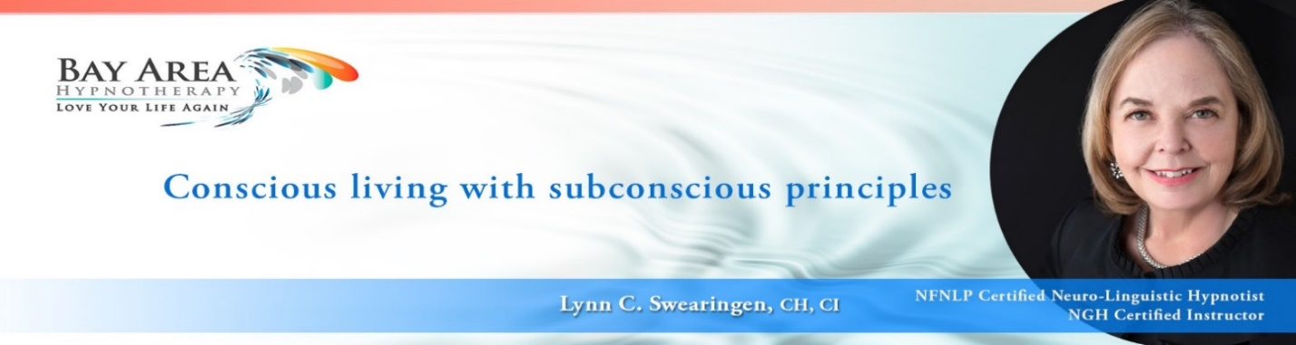

LESSON 24 HOMEWORK
How to Run a 6-Hour Self-Hypnosis Course

- Create a list of possible course titles. Remember, you’re not “selling” Self-Hypnosis, which is a vague concept for most people. You are selling the benefits. WHY do they want to attend this class? Create some compelling titles. For example, I once ran a workshop called Why Weight? The subtitle can be something like “Learn how to manage your weight with self-hypnosis”.
Your Self-Hypnosis workshop can be targeted to a specific niche you want to serve.

Brainstorm other titles for future workshops, using your structure for a 6-Hour workshop for other specific categories.

- Where will you conduct your course? For College students in a classroom? In a high school auditorium for students, parents, and teachers? In corporations? Will you rent space for the general public or do you have access to a venue?

- Create the structure for your own 6-Hour Self-Hypnosis Course. Using the provided structure, be as innovative as you wish. You can adapt the 6-hour structure to 2-hours, 3-hours, or even a full day. How will you present YOUR workshop? Include interactive exercises.

Present only the bullet points of what you will do from one point to the next. How long will you spend on each point? Simply put, “at this point I will ______.” At what points will you stop to teach steps 1, 2 and 3 of self-hypnosis? What handouts will you use? How will you teach basic assessment and goal assessment? And teach how to create suggestions with clear objectives, and then write a short encouragement and reinforcement script. How will they use this at home? It is essential to include how to formulate suggestions properly and put them to use.

Be prepared in the next Q&A to explain how you will teach your course.

YOU WILL NOW HAVE A CLEAR STRUCTURE THAT CAN BE APPLIED
TO EVERY FUTURE WORKSHOP, WHATEVER THE TOPIC.

