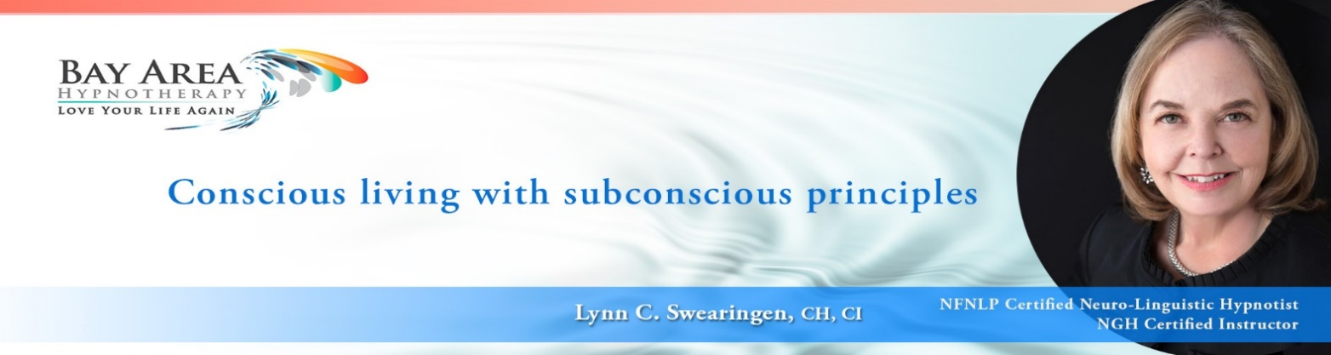

This is a valuable tool to stimulate your imagination
and help create powerful customized scripts for your clients.
TEMPLATE GENERATOR PDF:
TemplateGenerator.pdf (subliminalscience.com)

Dr. Richard Nongard is both a psychologist and hypnotherapist. He is also the President of the International Certification Board of Clinical Hypnotherapy (ICBCH).
His training always has solid content, very clear, easy to understand, and easy implement. I highly recommend him.
Look at his website www.subliminalscience.com for further training after you are certified.
This “Build Your Online Business in 2021” is a new offering on his home page.
I highly recommend ongoing training with Richard. His fees are affordable, and the content is high end.

L

