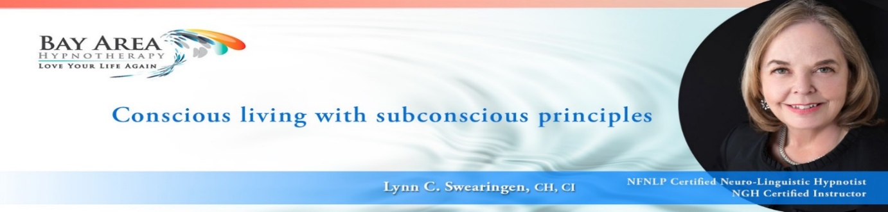

NGH HYPNOSIS CERTIFICATION TRAINING
EFFECTIVE USE OF SCRIPTS
ACTUAL CLIENT EXAMPLE: AMY
I developed a customized series of sessions for Amy, presenting with the following concerns:

- She had just stopped a compulsive alcohol problem and worried she would slip back
- She was going through a divorce
- Her Self-Image and Confidence had taken a big hit
- She was anxious due to uncertainties about the state of the world re Covid and her place in it and worry over how life would change after divorce.
HOW TO USE AND BLEND SCRIPTS TO MAKE THEM YOUR OWN
- Accumulate as many scripts as you can from a variety of sources you trust
- Create your own recipe for success for each individual client (you don’t just “read” a script; rather, you create within it a customized session built on your knowledge of the client)
- Combine resources into the perfect fit for your client
EXAMPLE SESSION:
Amy asked to do a session on self-love and appreciation (feeling validated within), combined with taming her harsh inner critic and also how she deals with anxiety.
I looked at my script library and chose 3 sources:
- NLP technique: First step, I used the induction in the script #2 below, but paused at the appropriate place to begin my favorite NLP technique to achieve self-appreciation, self-love and certainty of inherent worth and value (see thru the eyes of someone who loves you; hear their thoughts of love for you; feel their feelings of love for you, etc.) When finished, I resumed the script.
- 1st Script: (Tyrell) Taming the Harsh Inner Critic
- 2nd Script: (Cerbone) Attracting Abundance; Eliminate Negativity/Sadness – wonderfully written for reinforcement and confidence.
- Hypnotic Suggestion: Personalized hypnotic suggestions were reinforced throughout with the use of imagery

This combination employed a powerhouse of techniques, merging into an incredible experience for the client:
- First was a powerful NLP technique
- Second was a script with great imagery/visualizations and story/metaphor
- Third was a script full of authoritative suggestions, much like the famous Magic Script, totally empowering and exciting the client at the end of the session.

