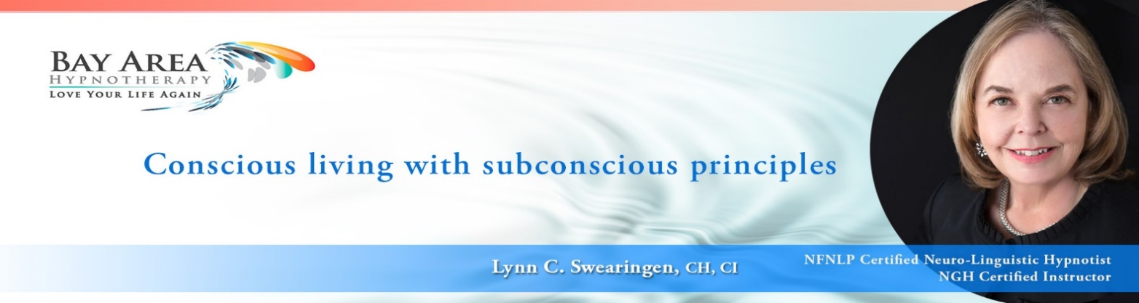

**EXAMPLES OF HYPNOTIC PATTER**

MAGIC WORDS: naturally, easily, effortlessly

WORDS THAT OPEN PERCEPTION: notice, curious, because, interesting

Nothing can bother, hurt, or disturb you …

Without effort, struggle, or strain …

Without worry, doubt or fear …

and **because** you already know how to relax, you can relax even deeper, here and now, as you listen to the sound of my voice …

**My voice will go with you**, helping you to feel calm and relaxed …

And **isn’t it curious, to notice** you feel safe in the world … safe in the world

**You may See, hear, sense, feel or simply know …**

**Isn’t it interesting** … so very interesting

You may **feel curious** …

You may **begin to notice** …

CONTINUALLY ESTABLISH SAFETY: where you feel safe … **safe in the world …**

ENGAGE THE SENSES: See what you see … hear what you hear … touch what you touch … perhaps you can enjoy lovely scents and aromas … perhaps you can taste something you love …

And **perhaps**, you **may begin to experience** a pleasant feeling of drowsiness …

Now there will have been a time and a place in your life, where you've felt perfectly relaxed, and perfectly at ease. And **I wonder** if you're able to get a sense of that right now?

**Soon … I don’t know when, but soon** … *(YOU ARE ESTABLISHING FUTURE TENSE … It WILL happen but we don’t know just when… BENEFIT: they build confidence, and you cannot fail because “soon” can be anytime but maybe not right now)*

And **notice** …

Look to the right of you … to the left of you

Look up and look down …

Look in front of you and in back of you …

Look above you and below you …

**Notice** what you **notice** ...

**You will be surprised and amazed** to **notice**

**Believe** it will happen … **Expect** it will happen … and **watch** it happen.

And **you forget to remember** … for longer and longer periods of time you forget to remember … you forget about ____________ ... ___________ is just something you *used* to do …

**That was then and this is now …**

SIMPLY BE: **Go to that place where you are no thing … no body … nowhere …**

FOR IMPRINTS:

**There is no person, thought, idea, memory, image, feeling, or sensation out of the past, in the present, or ever to arrive in the future that can stop me from being successful.**

You are now **remembering to remember** **who you really are …**

**I live life with a happy heart … a peaceful mind … and a playful spirit.**