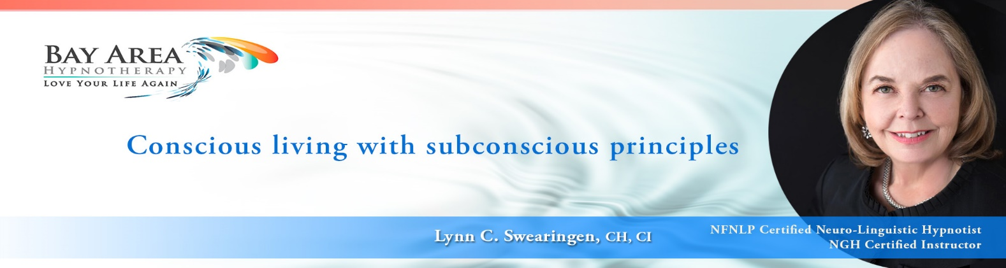

SUBSTANCE ABUSE / ADDICTION

Understand, as hypnotists, most of us are not trained addiction counselors. In most states we are not allowed to do what would be perceived as addiction counseling. However, there is a significant amount of work we can do to help our clients with compulsive behaviors, not only with hypnosis to facilitate behavioral change and wise choices, but also with sessions to address the whole person. For example, people suffering from addictions typically have suffered a huge hit to their confidence and self-esteem/self-respect. They are often self-loathing, feeling unlovable and unredeemable. They suffer from guilt, shame, anger, regret and more. All aspects of their lives are suffering, e.g. family, career, health and more. This is where a skilled hypnotist can save a life.

Remember and use this acronym, as you help an addict regain a sense of life balance and grounding. These are the red flags that lead to more substance abuse. When any one of these occur, it’s time to do a self-assessment and take care of the need to be addressed.

**HALT !!!**

**H**ungry

**A**ngry

**L**onely

**T**ired