**Conscious vs. Subconscious**

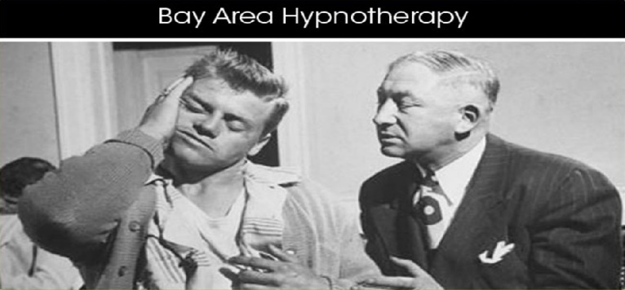  
  
Why do I try and fail and try and fail ???  
What's wrong with me!

You may not realize it but your conscious and subconscious minds can sometimes work independently of each other and often in conflict, causing a disconnect in your life that hinders you from reaching your goals. You also may not realize that *you have the power to directly access your subconscious to make suggestions for beneficial, permanent change*.    
  
A professional hypnotist can help you achieve your goals by use of *specific, agreed upon suggestions* to the subsconscious. You can access and heal painful memories, conquer irrational fears, gain control over bad habits and compulsive behavior, and literally remove obstacles to live a happy life. Achieve your highest goals and aspirations by *training your subconscious to work for you* to reach your full potential and LOVE YOUR LIFE AGAIN.

|  |  |
| --- | --- |
| **Traits of the**  **Conscious Mind**   * It is LOGICAL * Has SEQUENTIAL THOUGHTS * Easily ACCESSES short-term and some long-term memories * Uses WORDS/NUMBERS * and is ANALYTICAL   This is where THINKING * REASONING * AND * ACTION take place.  Your **Conscious** Mind  has a mind of its own!  Your conscious mind **does not** take suggestions very well. | **Traits of the**  **Sub-Conscious Mind**   * It is INTUITIVE * Has RANDOM THOUGHTS * Can ACCESS most lived MEMORIES and EXPERIENCES since childhood * It uses IMAGES/FEELINGS * and is CREATIVE   Your **Sub-Conscious** Mind is a dreamer!  dreaming while awake  (day-dreaming) and while asleep.  This is where PERMANENT * LASTING * BENEFICIAL CHANGE occurs.  Your subconscious mind **does** take suggestions very well. |