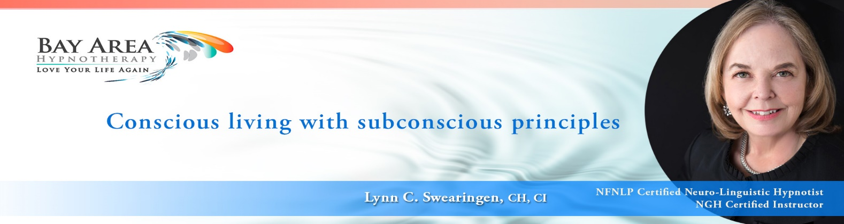

**Self-Hypnosis**

Smoke Cessation

**Waking/Auto Suggestion and Pre-Sleep Technique**

**STEP 1 – Change Your Story – Create a New Inner Dialogue**

**Waking/Auto Suggestion and Pre-Sleep Technique**

It is important to **faithfully practice this step twice daily** (once upon waking in the morning and once before going to sleep). If you already have a morning/evening ritual be sure to incorporate this into it.

Do this immediately upon wakingand just before you are ready to go to sleep, every day. Overtime, your suggestions will change or more will be added, but keep up this practice. This ritual will move you into your day with purpose, intention, and connection.

**You are a spirit inside a body which happens to have human thoughts and human emotions.**

**They are not who you are. You have control. You have choice.**

**Why first thing in the morning?** Doing this exercise before you get up in the morning sets you out with intention and purpose. You feel connected and engaged with the world. You will experience mindfulness and clarity. When the old, negative thoughts return, you will be aware and recognize them as unhelpful. It will be easy to cancel a thought and replace it with what you used in the morning exercise. In this way you begin to recalibrate throughout the day, continually bringing yourself back to mindful presence. After a while it becomes instinctive to do so.

**Why again before going to sleep?** It is our human default to ruminate about our worries and fears when we lie down to sleep. When you put a stress producing thought (an *OMG* or *What If* thought) into your subconscious before sleep, your subconscious will process that worry or fear all night long. You won’t go through the restorative cycles of sleep and will wake up, not only physically exhausted, but feeling emotionally stressed. By doing this exercise before sleep, you are intentionally choosing to feed your subconscious something you want it to process all night long. You will wake up restored and energized, feeling confident.

**NOTE:** All the suggestions below can be recited together as frequently as possible, as this is your NEW STORY, moving your subconscious in the direction of your goals. You can tell yourself the entirety of this story continually, throughout the day, reinforcing the new you. *It is only while doing the actual exercise that you choose only one suggestion.*

**EXERCISE INSTRUCTIONS:**

Lie in bed and say your chosen suggestion to yourself, *a minimum* of **ten times.** Give yourself an emotional reward, a payback at the end of the sentence. How would you like to feel now, e.g., calm, confident, happy, content, excited, motivated, energized, optimistic, hopeful, peaceful, in control? It doesn’t matter. This is YOUR emotional reward. You can change what I wrote if you like and replace it with something that might resonate with you even more. Just be sure it is positive and uplifting*.*

**BEGIN …** Choose one of the hypnotic suggestions.

*In order NOT to be distracted by counting,* every time you say the suggestion press down a finger on your right hand. When you run out of fingers, you know you’ve done five. It is purely sensory and not distracting. Then, continue with each finger of your left hand until you’ve completed the suggestion ten times. By using your fingers (just like a child) you will automatically know when you reach the count of ten. This frees your mind up to **IMAGINE** **yourself being successful in every way as you repeat your goal or affirmation**. *It generally takes at least 10 repetitions to begin FEELING the emotional reward at the end of the sentence. You need to connect emotionally to your suggestion.*

This may be your first attempt at learning to effectively program yourself through suggestion. It is of the utmost importance to do this exercise (repeating the ten repetitions) every morning upon waking and every night without falling asleep.

This is your **NEW STORY –** You are a **NON-SMOKER** now!

* I am a NON-Smoker and I feel proud … I feel happy.
* I am up to the challenge and I feel fierce to succeed.
* Smoking no longer works for me and I feel in control.
* I am taking m POWER BACK and I feel strong.
* I am an ACTOR in my life … no longer a RE-Actor … and I feel in control … I AM in control.
* I make choices that serve me … choices that support me … and I feel empowered.
* I reject the urge to smoke … I choose LIFE and I feel excited.
* One day at a time, I say NO to smoking and I feel motivated … I feel unstoppable.
* I OWN the habit … the habit doesn’t own me, and I feel powerful … I feel capable.
* There is always something better to do than smoke and I feel FREE.
* I am no longer a slave to smoking and I feel confident and in control.
* I am smart, capable, and determined … and I PERSIST AND SUCCEED.
* Every day I get better and better, and I feel confident.

*In order NOT to be distracted in the morning or to fall asleep in the evening,* every time you say the suggestion press down with each finger of your right hand. Then, continue with each finger of your left hand until you’ve completed the suggestion ten times. By using your fingers (just like children count on their fingers) you automatically know when you reach the count of ten. This frees your mind to **IMAGINE** yourself being successful in every way as you repeat your goal or affirmation. *And it takes at least 10 repetitions to begin FEELING the emotional reward at the end of the sentence. You need to connect emotionally to your suggestion.* IMPORTANT: **Use *the same* *suggestion* upon waking and before sleep**.

This may be your first attempt at learning to effectively program yourself through suggestion. It is of the utmost importance to do this exercise (repeating the ten repetitions) every morning upon waking and every night without falling asleep.

**You are beginning to establish a habit pattern of properly programming yourself by giving yourself positive suggestions upon waking and before going to sleep.** Every day you will find yourself reacting very positively to your suggestion. Over time these suggestions become so deeply rooted in your subconscious mind you will find yourself making positive and beneficial changes to your lifestyle ***without effort, struggle, or strain!***

|  |
| --- |
| **WARNING:** NEVER attempt Self-Hypnosis while driving or operating machinery. |
| *Remember, you are placing yourself in an altered state of consciousness.* |
|  |